Project Title: Industry-specific intelligent fire management system Project Design Phase-I - Solution Fit Team ID: PNT2022TMID18163

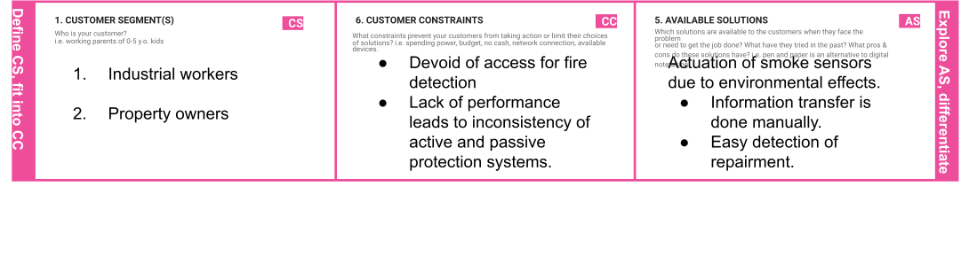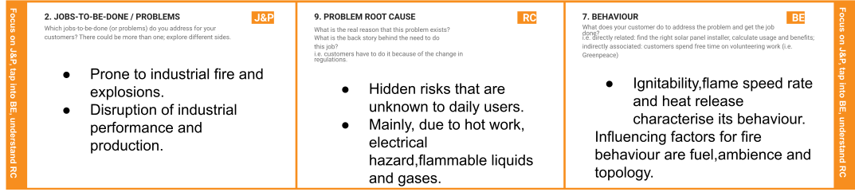

|  |  |  |  |  |
| --- | --- | --- | --- | --- |
|  | 1. **TRIGGERS TR**   What triggers customers to act? i.e. seeing their neighbour installing solar panels, reading about a more efﬁcient solution in the news.   * + **Early detection of errors**   + **No human intervention during ﬁre risks.**   + **Workers want to make their life safe and secure.** | 1. **YOUR SOLUTION SL**   If you are working on an existing business, write down your current solution ﬁrst, ﬁll in the canvas, and check how much it ﬁts reality.  If you are working on a new business proposition, then keep it blank until you ﬁll in the canvas and come up with a solution that ﬁts within customer limitations, solves a problem and matches customer behaviour.   * + **An IOT based industry-speciﬁc**   **,ﬁre management system that focuses on early detection and management of false alarms and errors**   * + **Implementation of wireless technologies in transferring messages** | 1. **CHANNELS of BEHAVIOUR CH**    1. **ONLINE**   What kind of actions do customers take online? Extract online channels from #7   * + - Testing and promotion of product through online   1. **OFFLINE**      + What kind of actions do customers take ofﬂine? Extract ofﬂine channels from #7 and use them for customer development.      + Testing and promotion of product through online      + Sticking onto the proposals given to the consumers. |  |

|  |  |  |  |  |
| --- | --- | --- | --- | --- |
|  | 1. **EMOTIONS: BEFORE / AFTER EM** How do customers feel when they face a problem or a job and afterwards?    * i.e. lost, insecure > conﬁdent, in control - use it in your communication strategy & design.    * Inconvenience of the workers for survival in the environment.    * Resultant product has a short life    * Highly reliable |  |  |  |